**Lab1: Write a Pandas program to create a dataframe from a dictionary and display it.**

**Sample data:**

**score={'Math':[78,85,96,80,86], 'English':[84,94,89,83,86],'Hindi':[86,97,96,72,83]}**

**Code:**

**import pandas as pd**

**# Sample data**

**score = {'Math': [78, 85, 96, 80, 86],**

**'English': [84, 94, 89, 83, 86],**

**'Hindi': [86, 97, 96, 72, 83]}**

**# Create DataFrame**

**df1 = pd.DataFrame(score)**

**# Display the DataFrame**

**print("Output:")**

**print(df1)**

**Output:**

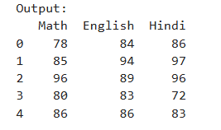

**Lab2: Write a Pandas program to create and display a DataFrame from a specified dictionary data which has the index labels.**

**Sample Python dictionary data and list labels:**

**exam_data = {'name': ['Anastasia', 'Dima', 'Katherine', 'James', 'Emily', 'Michael', 'Matthew', 'Laura', 'Kevin', 'Jonas'], 'score': [12.5, 9, 16.5, np.nan, 9, 20, 14.5, np.nan, 8, 19], 'attempts': [1, 3, 2, 3, 2, 3, 1, 1, 2, 1], 'qualify': ['yes', 'no', 'yes', 'no', 'no', 'yes', 'yes', 'no', 'no', 'yes']}**

**Code:  
import pandas as pd**

**import numpy as np**

**# Sample data**

**exam_data = {**

**'name': ['Anastasia', 'Dima', 'Katherine', 'James', 'Emily',**

**'Michael', 'Matthew', 'Laura', 'Kevin', 'Jonas'],**

**'score': [12.5, 9, 16.5, np.nan, 9, 20, 14.5, np.nan, 8, 19],**

**'attempts': [1, 3, 2, 3, 2, 3, 1, 1, 2, 1],**

**'qualify': ['yes', 'no', 'yes', 'no', 'no', 'yes', 'yes', 'no', 'no', 'yes']**

**}**

**# Create DataFrame with index labels**

**df2 = pd.DataFrame(exam_data)**

**# Display the DataFrame**

**print("\nOutput:")**

**print(df2)**

**Output:**

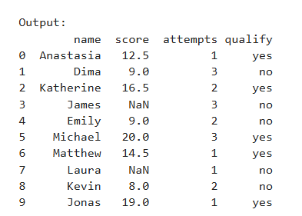

**Lab3: Write a Pandas program to get the first 3 rows of a given DataFrame.**

**Sample DataFrame:**

**exam_data = {'name': ['Anastasia', 'Dima', 'Katherine', 'James', 'Emily', 'Michael', 'Matthew', 'Laura', 'Kevin', 'Jonas'], 'score': [12.5, 9, 16.5, np.nan, 9, 20, 14.5, np.nan, 8, 19], 'attempts': [1, 3, 2, 3, 2, 3, 1, 1, 2, 1], 'qualify': ['yes', 'no', 'yes', 'no', 'no', 'yes', 'yes', 'no', 'no', 'yes']}**

**Code:**

**import pandas as pd**

**import numpy as np**

**# Sample data**

**exam_data = {**

**'name': ['Anastasia', 'Dima', 'Katherine', 'James', 'Emily',**

**'Michael', 'Matthew', 'Laura', 'Kevin', 'Jonas'],**

**'score': [12.5, 9, 16.5, np.nan, 9, 20, 14.5, np.nan, 8, 19],**

**'attempts': [1, 3, 2, 3, 2, 3, 1, 1, 2, 1],**

**'qualify': ['yes', 'no', 'yes', 'no', 'no', 'yes', 'yes', 'no', 'no', 'yes']**

**}**

**# Create DataFrame**

**df3 = pd.DataFrame(exam_data)**

**# Get the first 3 rows**

**print("\nOutput:")**

**print(df3.head(3))**

**Output:**

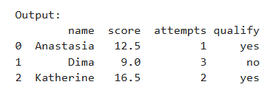

**Lab4: Write a Pandas program to select the 'name' and 'score' columns from the following DataFrame.**

**Sample Python dictionary data and list labels:**

**exam_data = {'name': ['Anastasia', 'Dima', 'Katherine', 'James', 'Emily', 'Michael', 'Matthew', 'Laura', 'Kevin', 'Jonas'], 'score': [12.5, 9, 16.5, np.nan, 9, 20, 14.5, np.nan, 8, 19], 'attempts': [1, 3, 2, 3, 2, 3, 1, 1, 2, 1], 'qualify': ['yes', 'no', 'yes', 'no', 'no', 'yes', 'yes', 'no', 'no', 'yes']}**

**Code:**

**import pandas as pd**

**import numpy as np**

**# Sample data**

**exam_data = {**

**'name': ['Anastasia', 'Dima', 'Katherine', 'James', 'Emily',**

**'Michael', 'Matthew', 'Laura', 'Kevin', 'Jonas'],**

**'score': [12.5, 9, 16.5, np.nan, 9, 20, 14.5, np.nan, 8, 19],**

**'attempts': [1, 3, 2, 3, 2, 3, 1, 1, 2, 1],**

**'qualify': ['yes', 'no', 'yes', 'no', 'no', 'yes', 'yes', 'no', 'no', 'yes']**

**}**

**# Create DataFrame**

**df4 = pd.DataFrame(exam_data)**

**# Select 'name' and 'score' columns**

**print("\nOutput:")**

**print(df4[['name', 'score']])**

**Output:**

